Git Repository Setup (Mac)

1. Set up a GitHub account, and once you do send me which email you used to make the account so I can add you to the collaborators list. The website is located at github.com
2. Once you are added to the collaborators list it is time to set up your file directory.
3. Follow this link and download the Git for Windows 2.5.1 (<https://github.com/git-for-windows/git/releases/download/v2.5.1.windows.1/Git-2.5.1-64-bit.exe>). Once you choose the download location you will be greeted with this window:   
     
   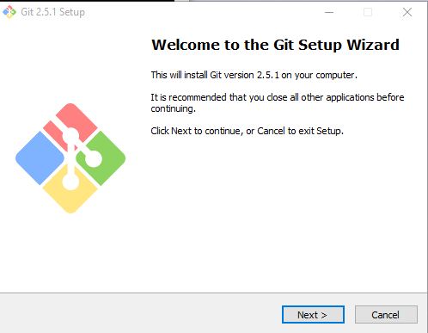  
     
   Click Next, click next again to accept the terms and conditions, select your install location and click next again. Leave all of the check marks as is, it should look like this:  
     
   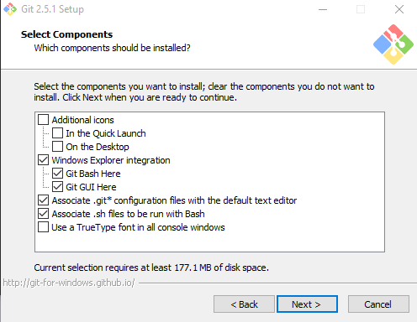  
     
   Click next and on the next window click next again and just leave the folder name as Git. On the next window choose the second option ‘Use Git from the Windows Command Prompt’:   
     
   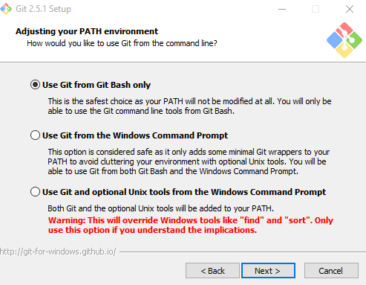  
   Now click next, and leave this as the default option ‘Checkout Windows-style, commit Unix-style line endings’. Click next. Choose the second option ‘Use Windows’ default console window’ as shown below:   
     
   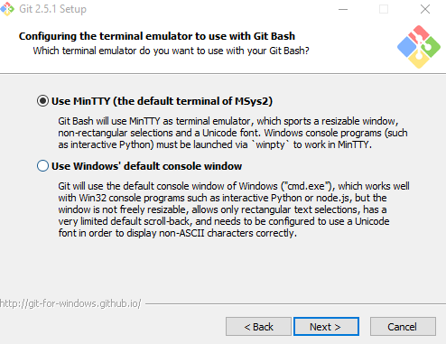  
     
   Click next, leave the ‘Enable file system caching’ unchecked and click next and the program will start to install. Finally click ‘Finish’ and the program should be done installing.
4. Finally we are ready to set up your file system. Press the windows key, start typing ‘cmd’ and when command prompt shows up hit enter. It should look something like this:   
     
   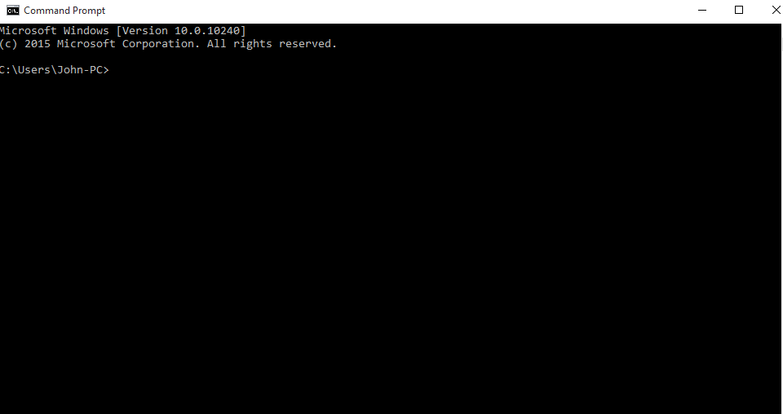
5. Navigate to your desired working directory, so if you would like the folder to be on your desktop in a folder named ‘Senior Projects’, type in the following:  
     
   cd Desktop/“Senior Projects”  
     
   After you type this in, your command prompt should look something like this:   
     
   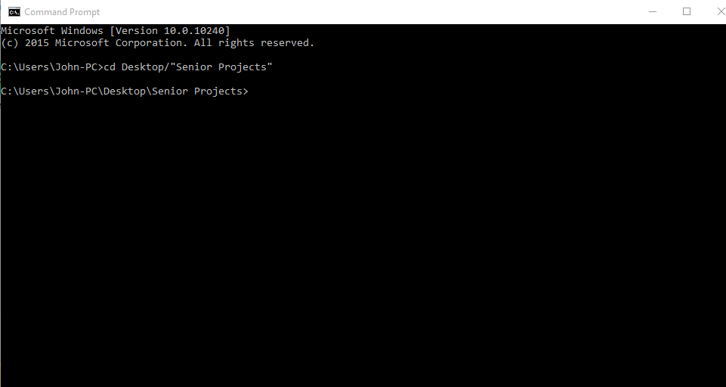
6. Now that you are here, you need to type the following command to copy the git repository to your personal file directory:  
     
   git clone <https://github.com/JohnThom212/INFERNO.git>  
     
   Now your command window should look like this, once the command finishes:  
     
   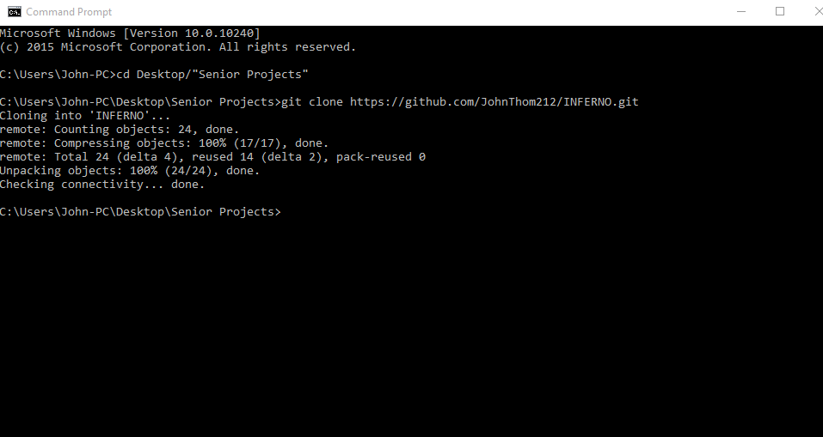
7. Now that we have the directory set up you should be able to cd into the directory, and then look at what is already in the directory by typing in:  
     
   cd INFERNO  
   dir

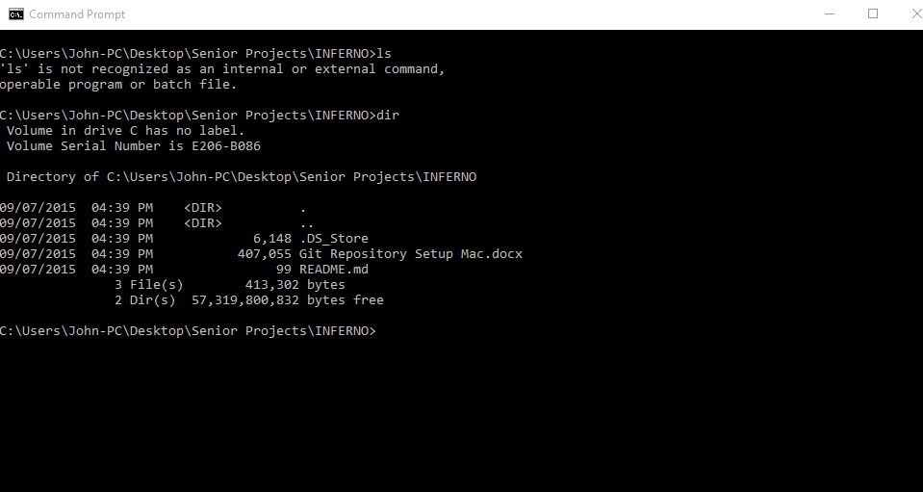

1. So that I can ensure you have gained access to the repository you should edit the README.md file and insert your contact information, you can open this file in any text editor. If you have trouble with this contact me and I can help you.
2. Now on to adding, commiting, and pushing. Once you have edited the file you need to add it, commit it, and push it so that everyone else can see it. Once you have edited the file if you type in the command:  
     
   git status  
     
   You will see this:  
     
   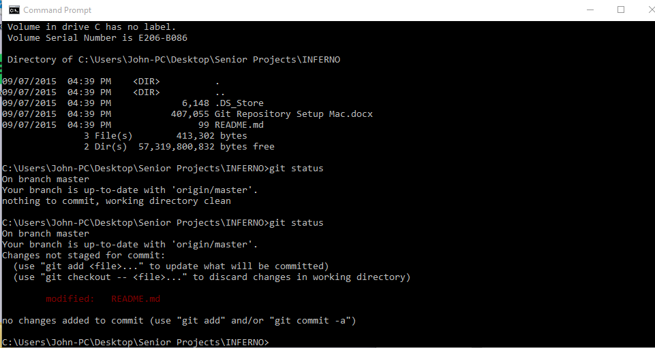  
   This shows that the README.md file has been modified, now you need to add the file and commit it. To add the file type:  
     
   git add .  
     
   The ‘.’ At the end means you are adding all altered files so that later on you do not have to add every altered file individually but you could also type:  
     
   git add README.md  
     
   This would add only the one file that you altered. After you add the file your terminal window should not say anything. Next you need to commit files that you have added. To do this type the following:  
     
   git commit –m “Edited README”  
     
   The –m flag allows you to add a commit message explaining what you did, and you should always provide a commit message to say what you have done. Once you have committed your command window will look like this:  
     
   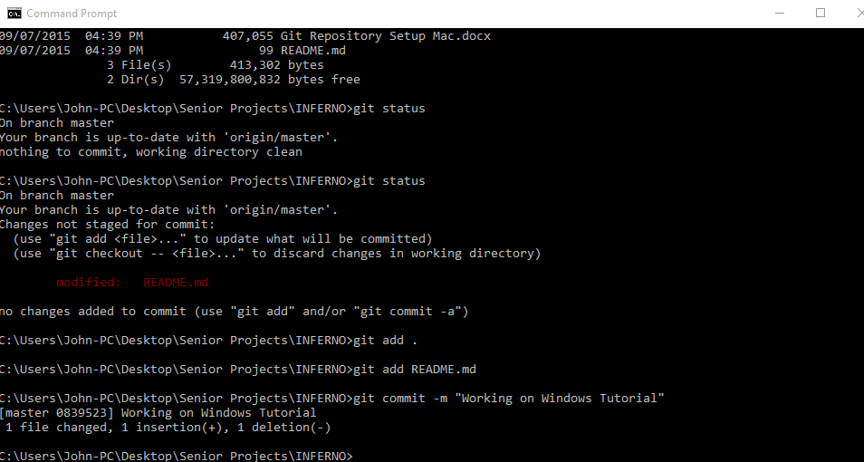  
   Now the last thing to do is push the files back to the repository because everything you have done thus far has been on you local machine, to do this type in the following (it will request you put in your git hub user name and password but only the first time you do this):  
     
   git push origin master  
     
   now your command prompt should look like this:  
     
   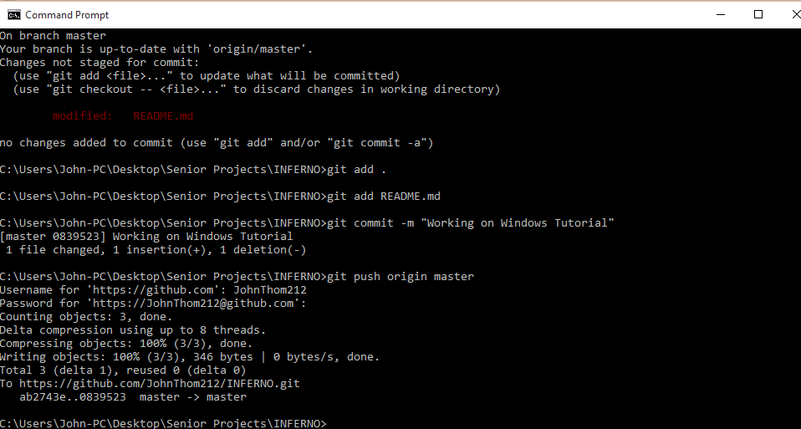
3. Now you are done, however every time you enter this folder to work on things you need to pull everything down from the repository so that you make sure you are always working on the most current documents. This command is simply:  
     
   git pull  
     
   This should look like this in command prompt:  
   